**Uninformed & Informed Search Algorithms**

**Preamble**

Uninformed Search Algorithms does not use any domain knowledge. This means that it does not use any information like closeness or location of the goal to find the goal state, whereas Informed Search Algorithms uses domain knowledge to find goal state. In this tutorial, we will implement various Uninformed & Informed Search Algorithms using Scilab/Python.

An uninformed ( blind, brute-force) search algorithm generates the search tree without using any domain specific knowledge.

Following are the Examples:

1. Breadth First Search
2. Depth First Search
3. Uniform Cost Search

An Informed search algorithm have information on the goal state, which helps in more efficient searching. This information is obtained by something called a heuristic.

Following are the examples:

1. Greedy Search
2. A* Tree Search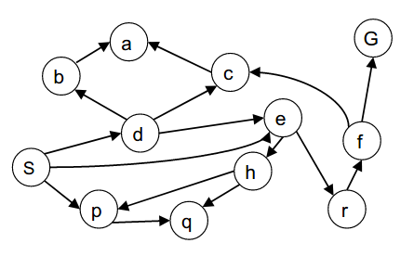

**Exercise 1**:Write a script toimplement Breadth First Search algorithm for the above mentioned graph. Also find the Expansion path from node S to Node G (where S is source node and G is Goal node).

**Exercise 2 :** Write a script toimplement Depth First Search(DFS) algorithm for the above mentioned graph. Also find the Expansion path from node S to Node G (where S is source node and G is Goal node).

* Compare it with BFS Expansion path.

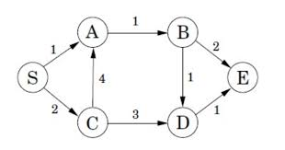

**Exercise 3:** Write a script toimplement A* Search algorithm for the above mentioned graph. Also find the optimal cost when traversing from node S to Node E (where S is source node and E is Goal node.

References:

1. <https://courses.cs.washington.edu/courses/cse473/14sp/slides/3-search.pdf>
2. http://pages.cs.wisc.edu/~dyer/cs540/notes/search1.html